

Mini Project Report
On
Transaction Management System

SUBMITTED BY: SUBMITTEDTO:
Ayush Thakur Ms.Amandeep Kaur
UID: 26MCI10311 Assistant Professor
CLASS: MCA (AI&ML)
Course Code: 26CAP-602
SECTION: 26MAM5(B)

Table ofContent

S.No. | Name | Page no.
Chapter 1 | Introduction/Background | 4
Chapter 2 | Objective/ Technologies Used | 4
Chapter 3 | Technologies Used | 4
Chapter 4 | Requirements and System Design | 5-6
Chapter 5 | Source Code & Output | 7-12
Chapter 6 | Functionalities | 13
Chapter 7 | Conclusion/Future Work/ Learning Out comes | 14

DECLARATION

I, Ayush Thakur, student of MCA (AI & ML) at Chandigarh University, hereby

declare that the mini-project entitled “Transaction Management System” has been

prepared and submitted by me as part of my academic work. I declare that the

information presented in this report is true to the best of my knowledge. The project

work has been carried out for academic purposes under the guidance of

Ms.Amandeep Kaur, Assistant Professor. Any external resources, references, or

assistance used in Preparing this project should be appropriately acknowledged. I

understand that I am responsible for ensuring the originality and accuracy of the

submitted work and for following the university's academic integrity guidelines.

Student Signature: ________

Name: Ayush Thakur (UID: 26MCI10311)

Date: ________

ACKNOWLEDGEMENT

I would like to express my sincere gratitude to Ms. Amandeep Kaur, Assistant

Professor, for his valuable guidance, support, and encouragement throughout the

development of my mini-project entitled “Transaction Management System.” I am thankful to Chandigarh University for providing me with the opportunity and resources to undertake this project as part of my MCA (AI & ML) course. This project helped me gain practical knowledge of Python programming, graph data structures, and shortest-path algorithms. I would also like to thank my teachers, classmates, and everyone who directly or indirectly supported me in completing this project successfully.

Finally, I am grateful for the opportunity to apply my theoretical knowledge to a practical problem and improve my programming and problem-solving skills.

Thank you

CHAPTER 1: INTRODUCTION AND BACKGROUND

1.1 Introduction to Transaction Management System:
A Transaction Management System is a software application used to manage, record, and monitor financial or other transactions. It helps users perform transactions, maintain transaction records, and view transaction history accurately. The main purpose of this project is to provide an easy, efficient, and reliable way to manage transactions. The system can store transaction details such as transaction ID, date, amount, transaction type, and status.

1.2 Background of the Project:
In traditional systems, transactions are often recorded manually in registers or spreadsheets. This process can be time-consuming and may lead to errors, data loss, or difficulty tracking previous transactions. The Transaction Management System is developed to overcome these problems by maintaining transaction records digitally. It helps users manage transactions efficiently, retrieve information quickly, and maintain organized records.

1.3 Problem Statement:
Managing transactions manually can create several problems, such as:
- Difficulty maintaining transaction records.
- Errors during data entry and calculations.
- Time-consuming searching and updating of records.
- Difficulty tracking transaction history.
- Risk of losing important transaction information.
Therefore, a computerized Transaction Management System is needed to store, manage, and retrieve transaction information efficiently and accurately.

1.4 Purpose of the Project:
The main purpose of this project is to develop a system that simplifies transaction management. The purposes are:
- To record and manage transaction details.
- To store transaction information in a database.
- To provide easy access to transaction history.
- To reduce manual work and human errors.
- To improve the accuracy and organization of records.
- To make transaction information easy to search and update.

1.5 Scope of the Project:
The scope of the Transaction Management System includes the following features:
- Transaction recording: Add new transaction details.
- Transaction viewing: Display all recorded transactions.
- Transaction updating: Modify transaction details when required.
- Transaction deletion: Remove records when authorized.
- Transaction history: View previous transactions.
- Database management: Store and retrieve transaction records.
- Report generation: Display transaction summaries and reports.

CHAPTER 2: OBJECTIVES AND TECHNOLOGIES USED

2.1 Objectives of the Project:
The main objective of the Transaction Management System is to develop a simple and efficient application for managing transaction records. The objectives are:
- To maintain transaction records digitally.
- To store transaction details securely in a database.
- To make it easy to add, view, update, and delete transactions.
- To reduce manual work and human errors.
- To provide quick access to transaction history.
- To improve the accuracy and efficiency of transaction management.

2.2 Existing System:
In the existing system, transactions may be maintained manually using registers, paper records, or spreadsheets. Managing a large number of transactions using these methods can be difficult.
Disadvantages of the existing system:
- Time-consuming record management.
- Possibility of human errors.
- Difficulty searching for old transactions.
- Risk of data loss.
- Difficulty generating transaction reports.

2.3 Proposed System:
The proposed Transaction Management System provides a computerized method for maintaining transaction records. It allows users to store, view, update, and manage transaction information through a user-friendly interface.
Advantages of the proposed system:
- Easy transaction management.
- Faster data retrieval.
- Improved accuracy.
- Organized transaction history.
- Reduced paperwork.
- Easier report generation.

2.4 Technologies Used:
The technologies depend on the programming languages and tools used to develop the project. A possible technology stack is:
- Frontend: HTML, CSS and JavaScript.
- Backend: Python.
- Database: MySQL.
- Code Editor: Visual Studio Code.
- Operating System: Windows.
Use only the technologies actually used in your project.

2.5 Advantages of the System:
The major advantages of the Transaction Management System are:
- Efficiency: Transactions can be recorded and retrieved quickly.
- Accuracy: Reduces errors caused by manual record keeping.
- Easy Access: Users can view transaction details conveniently.
- Data Organization: Records are maintained in a structured format.
- Time Saving: Reduces the time required to manage transactions.
- Future Expansion: Additional features can be added when required.

CHAPTER 3 :TECHNOLOGIES USED

3.1 Introduction to Front-End Technology:
Front-end technology is used to design the user interface of a Transaction Management System. It allows users to interact with the application and perform different operations. HTML: HTML (Hyper Text Markup Language) is used to create the structure of web pages, such as forms, buttons, tables, and headings. CSS: CSS (Cascading Style Sheets) is used to improve the appearance of web pages by adding colors, layouts, fonts, and spacing. JavaScript: JavaScript is used to make web pages interactive and handle user actions.

3.2 Introduction to Back-End Technology:
Back-end technology manages the internal operations of the application, including processing user requests, validating data, and communicating with the database. Python: Python is a high-level programming language used to develop application logic. It can process transaction details and connect the application to a database.

3.3 Database Technology:
A database is used to store and manage transaction information in an organized manner. My SQL: My SQL is a relational database management system used to store transaction records in tables. The database may contain the following fields:
- Transaction ID
- Transaction Date
- Transaction Type
- Transaction Amount
- Transaction Description
- Transaction Status

3.4 Software and Hardware Requirements:
Software requirements
- Operating System: Windows
- Front-end: HTML, CSS and JavaScript
- Back-end: Python
- Database: MySQL
- Code Editor: Visual Studio Cod
Hardware requirements
- Processor: Intel Core i3 or equivalent
- RAM: Minimum 4 GB
- Storage: Minimum 10 GB of available space
- Display: Standard computer monitor
- Input Devices: Keyboard and mouse

3.5 Tools and Platforms Used:
Visual Studio Code: Used to write and edit the source code.
Web Browser: Used to run and test the web application.
My SQL: Used to store and retrieve transaction records.
Python: Used to implement the application's functionality and process transaction data.

CHAPTER 4: Requirements and System Design

4.1 Functional Requirements:
Functional requirements describe the main functions performed by the Transaction Management System.
- Add Transaction: The user can enter and save new transaction details.
- View Transaction: The user can view all stored transactions.
- Update Transaction: The user can modify existing transaction information.
- Delete Transaction: The user can delete a transaction record when authorized.
- Search Transaction: The user can search for transactions using a transaction ID or other details.
- View Transaction History: The user can view previous transaction records.
- Generate Reports: The system can display transaction summaries.

4.2 Non-Functional Requirements:
Non-functional requirements describe the quality and performance of the system.
- Security: Transaction information should be protected from unauthorized access.
- Performance: The system should respond quickly to user requests.
- Reliability: The system should store and retrieve records correctly.
- Usability: The interface should be simple and easy to understand.
- Maintainability: The system should be easy to update and improve.
- Availability: The system should be accessible whenever required, subject to its hosting environment.

4.3 System Architecture:
The system architecture explains how different components of the application communicate with one another.
The Transaction Management System can use a three-layer architecture:
- Presentation Layer: Provides the user interface.
- Application Layer: Processes requests and applies transaction rules.
- Database Layer: Stores and retrieves transaction records.
System workflow:
User → User Interface → Application Logic → Database → Result Displayed to User

4.4 Data Flow Diagram (DFD):
A Data Flow Diagram represents how information moves through the system.
Level 0 DFD:
- The user enters transaction details.
- The system processes the request.
- The database stores or retrieves the information.
- The system displays the result to the user.
User
Enters transaction details
Transaction Management System
Processes requests
Database
Stores transaction records
Result displayed to user

4.5 Entity Relationship Diagram (ER Diagram):
An Entity Relationship Diagram represents the entities and their relationships in a database. The main entity is Transaction, which can contain:
- Transaction_ID (Primary Key)
- Transaction_Date
- Transaction_Type
- Amount
- Description
- Status
If the system supports multiple users, a User entity can also be included.
Example relationship:
User (1) → (Many) Transactions
One user can create or manage multiple transactions.

4.6 Database Design:
The database stores transaction information in a structured table.
Example: Transactions table
Field Name | Data Type | Description
transaction_id | INT | Unique transaction ID
transaction_date | DATE | Date of transaction
transaction_type | VARCHAR(20) | Income or expense
Amount | DECIMAL(10,2) | Transaction amount
Description | VARCHAR(255) | Transaction details
Status | VARCHAR(20) | Transaction status
The transaction_id field acts as the primary key to identify each transaction uniquely.

4.7 Use Case Diagram:
A Use Case Diagram shows the interaction between a user and the system.
Actor: User
Use cases:
- Add transaction
- View transactions
- Update transaction
- Delete transaction
- Search transaction
- View transaction history
- Generate reports
The user interacts with the system to perform these operations according to the permissions provided.

CHAPTER 5: SOURCE CODE AND OUTPUT

Source Code:

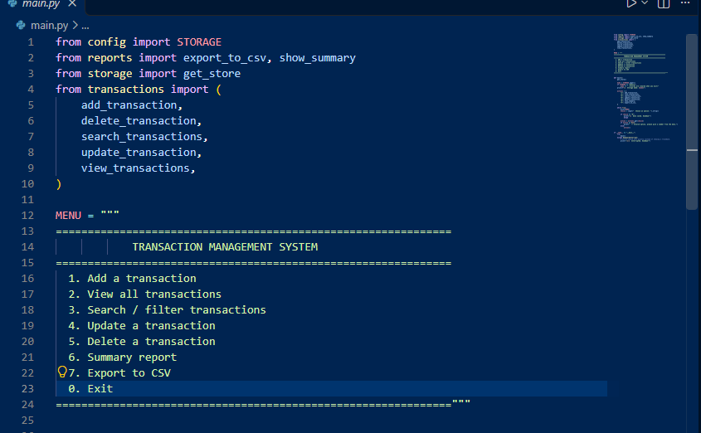

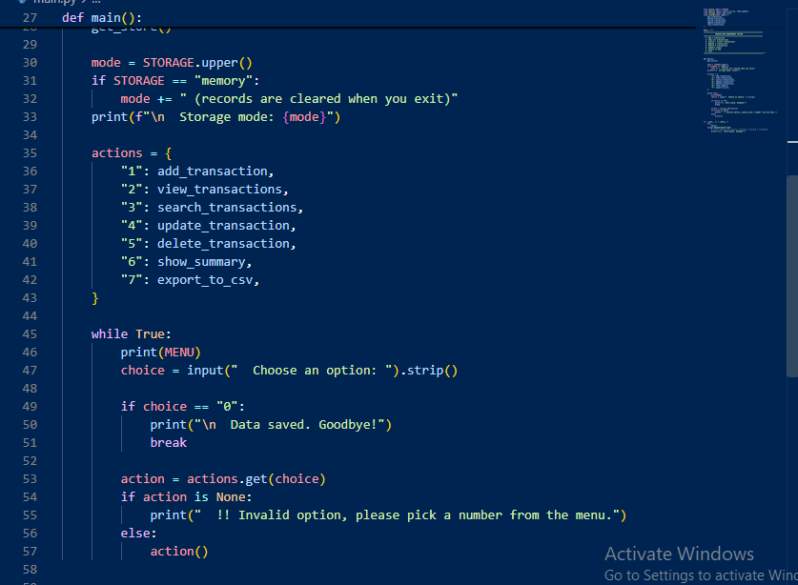

Output:

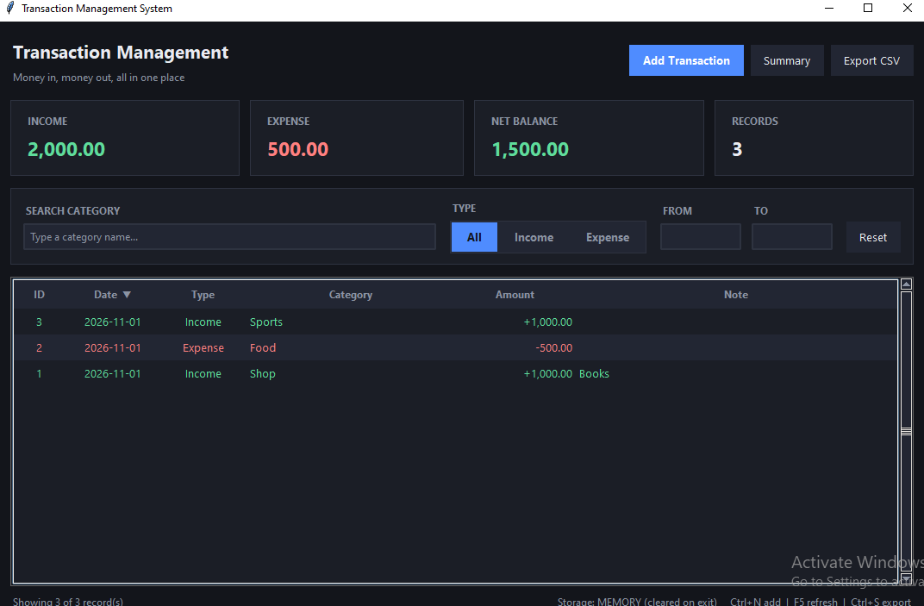

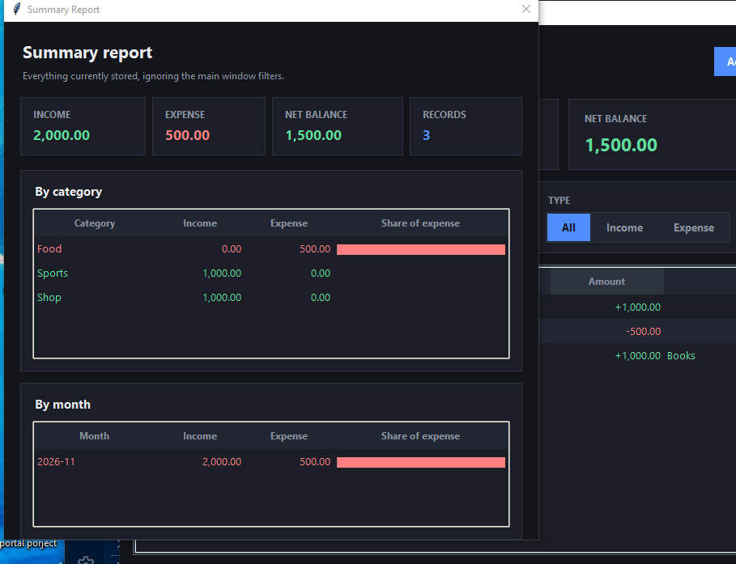

CHAPTER 6: Future Enhancements

6.1 Current Limitations:
The Transaction Management System is designed to manage basic transaction records. However, the current sample implementation has some limitations.
- Data is stored temporarily in memory.
- Records are lost when the program is closed.
- User login and registration are not implemented.
- The system does not include advanced reporting features.
- Transaction data is not connected to a permanent database.
- Data validation and security features are limited.

6.2 Future Scope:
The system can be improved in the future by adding advanced features that make transaction management easier and more reliable.
- Integration with a My SQL database for permanent storage.
- User registration and secure login.
- Transaction search and filtering.
- Monthly and yearly transaction reports.
- Income and expense tracking.
- Automatic calculation of total income and expenses.
- A graphical user interface for better usability.

6.3 Proposed Improvements:
The following improvements can make the system more useful:
- Database Integration: Store transaction records permanently in a database.
- Improved Interface: Develop a user-friendly interface using web technologies or a desktop GUI.
- Data Validation: Prevent invalid amounts and incomplete transaction details.
- Report Generation: Generate reports based on transaction dates and types.
- Backup and Recovery: Provide backup facilities to help prevent data loss.
- Search Functionality: Allow users to find specific transactions quickly.

6.4 Security Enhancements:
Security is important for protecting transaction information. Future versions can include:
- Password hashing for secure user authentication.
- Role-based access control.
- Input validation to prevent invalid data.
- Secure database connections.
- Regular database backups.
- Audit logs to record important changes.

CHAPTER 7: Conclusion, Future Work and Learning Outcomes

7.1 Conclusion:
The Transaction Management System is a simple application designed to manage and maintain transaction records efficiently. It provides basic features for adding and viewing transaction details. This project helps reduce manual work and makes transaction information easier to organize and access. It also demonstrates the practical use of programming concepts, including functions, lists, dictionaries, conditional statements, and loops in Python. The project can be further improved by integrating a database, adding user authentication, and developing a graphical user interface. Overall, this project provides a foundation for understanding how transaction management applications are developed.

7.2 Future Work:
In the future, the Transaction Management System can be enhanced with the following features:
- Integration with a MySQL database for permanent data storage.
- Secure login and registration for multiple users.
- Automatic calculation of total income and expenses.
- Generation of monthly and yearly transaction reports.
- Graphical representation of transaction data using charts.
- Exporting transaction reports to PDF or Excel.
- Improved security and backup facilities.
These features can make the system more practical and suitable for real-world use.

7.3 Learning Outcomes:
While developing this project, the following concepts can be learned:
- Understanding the fundamentals of transaction management.
- Applying Python programming concepts to a practical project.
- Using functions to organize program code.
- Managing records using lists and dictionaries.
- Applying conditional statements and loops.
- Understanding database integration and data storage.
- Learning basic software testing and debugging.
- Understanding system requirements and project documentation.

7.4 References:
The following resources can be used to learn about the technologies and concepts used in this project.
- Python Official Documentation — https://docs.python.org/3/
- W3Schools HTML Tutorial — https://www.w3schools.com/html/
- W3Schools CSS Tutorial — https://www.w3schools.com/css/
- W3Schools JavaScript Tutorial — https://www.w3schools.com/js/
- My SQL Official Documentation — https://dev.mysql.com/doc/

